Romance scams take record dollars in 2020
They say love hurts. With romance scams that’s doubly true – hearts are broken and wallets are emptied. For three years running, people have reported losing more money on romance scams than on any other fraud type identified in Sentinel. In 2020, reported losses to romance scams reached a record $304 million, up about 50% from 2019. For an individual, that meant a median dollar loss of $2,500. From 2016 to 2020, reported total dollar losses increased more than fourfold, and the number of reports nearly tripled.
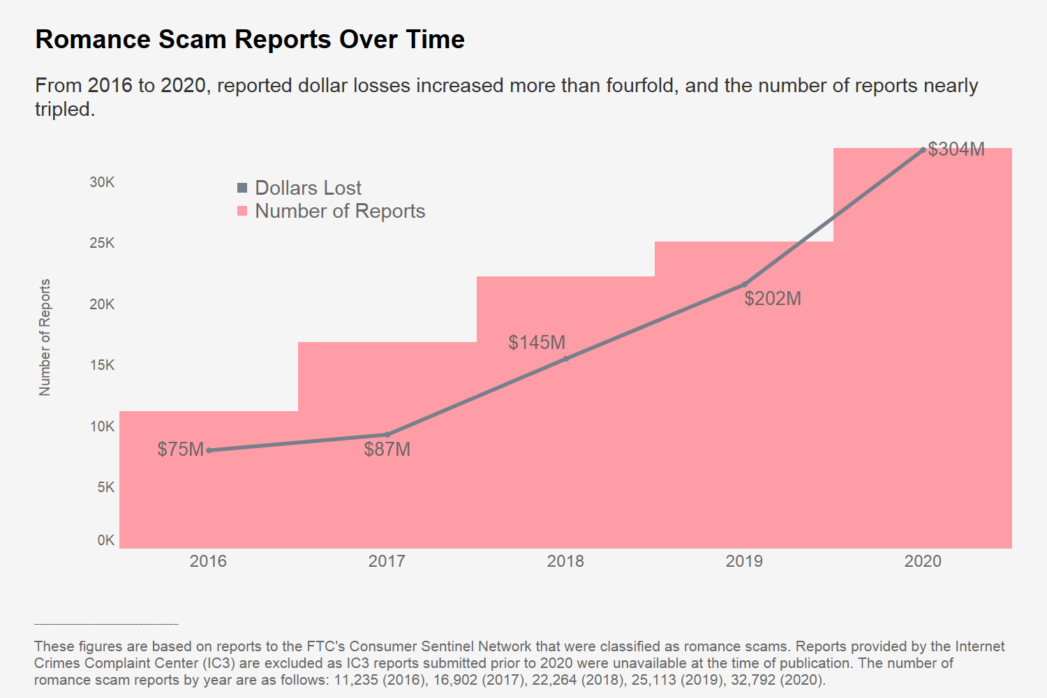
It is reasonable to wonder: what happened in 2020 to make these dollars losses continue to spike? An obvious reason may be the pandemic limiting our ability to meet in person. But outside the pandemic, the share of people who have ever used an online dating site or app has also been rising. And romance scammers are primed to take advantage. Scammers fabricate attractive online profiles to draw people in, often lifting pictures from the web and using made up names. Some go a step further and assume the identities of real people. Once they make online contact, they make up reasons not to meet in person. The pandemic has both made that easier and inspired new twists to their stories, with many people reporting that their so-called suitor claimed to be unable to travel because of the pandemic. Some scammers have reportedly even canceled first date plans due to a supposed positive COVID-19 test.
While many people report losing money on romance scams that start on dating apps, even more say they were targeted on social media. These social media users aren’t always looking for love, and report that the scam often starts with an unexpected friend request or message.
Sooner or later, these scammers always ask for money. They might say it’s for a phone card to keep chatting. Or they might claim it’s for a medical emergency, with COVID-19 often sprinkled into their tales of woe. The stories are endless, and can create a sense of urgency that pushes people to send money over and over again.
What many of the largest reported dollar losses have in common is that people believe their new partner has actually sent them a large sum of money. Scammers claim to have sent money for a cooked-up reason, and then have a detailed story about why the money needs to be sent back to them or on to someone else. People think they’re helping someone they care about, but they may actually be laundering stolen funds. In fact, many reported that the money they received and forwarded on turned out to be stolen unemployment benefits.
In 2020, reports of gift cards being used to send money to romance scammers increased by nearly 70%. Gift cards, along with wire transfers, are the most frequently reported payment methods for romance scams. People said they mailed the gift cards or gave the card’s PIN number to the scammer. The median amount people sent romance scammers in 2020 using any method of payment was $2,500, more than ten times the median loss across all other fraud types.
Reports of money lost on romance scams increased for every age group in 2020. People ages 20 to 29 saw the most striking increase, with the number of reports more than doubling since 2019. People ages 40 to 69 were once again the most likely to report losing money to romance scams. And people 70 and older reported the highest individual median losses at $9,475.
So how can you play it safe while looking for love online? Here are some tips to help you steer clear of scammers:
- Never send money or gifts to someone you haven’t met in person – even if they send you money first.
- Talk to someone you trust about this new love interest. It can be easy to miss things that don’t add up. So pay attention if your friends or family are concerned.
- Take it slowly. Ask questions and look for inconsistent answers.
- Try a reverse-image search of the profile pictures. If they’re associated with another name or with details that don’t match up, it’s a scam.
- Learn more at ftc.gov/romancescams.

Help stop scammers by reporting suspicious profiles or messages to the dating app or social media platform. Then, tell the FTC at ReportFraud.ftc.gov.

The analysis is based on self-reported data from consumers that is stored in the FTC’s Consumer Sentinel Database. It is not a survey that measures prevalence of this particular scam. This analysis excludes fraud reports classified as “Other misc.”
Losses sustained in these scams are reported by consumers but not independently verified. These figures and figures throughout this Spotlight are based on reports to the FTC's Consumer Sentinel Network that were classified as romance scams, excluding reports provided by the Internet Crimes Complaint Center (IC3). IC3 reports submitted prior to 2020 were unavailable at the time of publication, so these reports were excluded to ensure greater consistency in reporting trends over time.
According to the Pew Research Center, the “share of Americans who have used these platforms – as well as the share who have found a spouse or partner through them – has risen over time.” See Monica Anderson, Emily A. Vogels, and Erica Turner, Pew Research Center, The Virtues and Downsides of Online Dating (Feb. 2020, Rev. Jan. 2021), at 3, available at https://www.pewresearch.org/internet/2020/02/06/the-virtues-and-downsides-of-online-dating/.
This finding is based on keyword analysis of 2020 Consumer Sentinel Reports classified as a romance scams and indicating a dollar loss. Of these, 2,276 reports mentioned the dating apps Ashley Madison, BLK, Bumble, Chispa, Coffee Meets Bagel, eharmony, EliteSingles, FriendFinder, Grindr, Hinge, Match, OkCupid, OurTime, Plenty of Fish, Seeking Arrangement, SilverSingles, Tinder, WooPlus, or Zoosk. Another 5,924 mentioned Facebook or Instagram. Reports that mentioned one of the specified dating apps and also Facebook or Instagram were excluded from the Facebook or Instagram figure. Because these numbers have not been normalized based on the number of users, they should not be understood as an indication that an individual user of Facebook or Instagram is more likely to encounter a romance scam as compared to users of these dating apps.
Wire transfer refers to payments made by wire transfer services such as MoneyGram and Western Union. Gift cards include reload cards (e.g., MoneyPak).
Median loss calculations are based on reports indicating a monetary loss of $1 to $999,999. Reports provided by MoneyGram, Western Union, and Green Dot are excluded for this calculation as these data contributors report each transaction separately, which typically affects calculation of an individual’s median loss. The median individual reported loss for all frauds in 2020, excluding romance scams, was $240.
In 2020, 62% of romance scam reports included in this Spotlight included age information. This age comparison is normalized based on the number of loss reports per million population by age during this period. Population numbers were obtained from the U.S. Census Bureau Annual Estimates of the Resident Population for Selected Age Groups by Sex for the United States (June 2020).
See endnote 6.

